

Module title: SOFTWARE ENGINEERING PRINCIPLES AND PRACTICES
Module code: COMP70066
Module leader: Dr. Ateeq Ur Rehman
Group Report: Restaurant Review Portal (RestoReview)

Submitted by:
Project Team
Muhammed Awais Amjad
Aishwarya Sebastian
Govind Krishnan Radhakrishnan
Neeraj Kumar

Submitted on:09/01/2026

DATED 21ST OCT 2025
SOFTWARE DEVELOPMENT AGREEMENT
between
Govind Krishnan Radhakrishnan
Aishwarya Sebastian
Muhammed Awais Amjad
Neeraj Kumar
and WINREX(Group1)

THIS AGREEMENT is entered into on 21st Oct 2025 (the “Agreement”). between
1. Govind Krishnan Radhakrishnan And
2. Aishwarya Sebastian
3. Muhammed Awias Amjad
4. Neeraj Kumar
Working as part of

WINREX

Introduction

- The Developer is engaged in the business of software development.

B) The Client wishes to acquire Software, as well as other Work Products and Services that meet the Client's Roadmap.

C) There have been discussions between the parties, and the Developer has expressly represented to the Client that it has the capability to develop Software (and deliver other Work Products and Services) that are appropriate for and fulfil the requirements of the Client's Roadmap.

D) In reliance on the representations alluded to at recital (c) above, the Client wishes to engage the Developer, and the Developer wishes to accept such engagement by the Client, to provide under this Agreement: the Software; the Services; and, other Work Products, in accordance with the Roadmap set out in the Heads of Terms agreement. This agreement signifies acceptance of a professional contribution to the collective “Heads of Terms” agreement signed by the “Developer” and the “Customer” and the contractual terms and conditions contained within the contract agreement governing delivery of the project. This agreement defines the contractual obligation of the individual contractor to the developer group.

Agreed Terms
• We all promise to listen to each other’s ideas with respect
• We all promise to do your work as best as we can
• We all promise to do our work on time
• We all promise to contribute equally to development, documentation and presentations.
• We all promise that all internal discussions, designs and project materials must remain confidential within team
We shall be credited equally in any submission, presentation or publication related to the project
• We all agreed to keep client data, details and confidential information.
• Any absence or issue affecting progress must be informed to the team and client in advance.
• We all team members must maintain professionalism and teamwork throughout the project.
• This agreement remains valid for the duration of the project and may be amended only with the consent of all parties.
• We all team members are signed to each other on this project.

In Witness Whereof, the duly authorized representatives of the parties hereto have caused this Agreement to be executed on the date first written above.
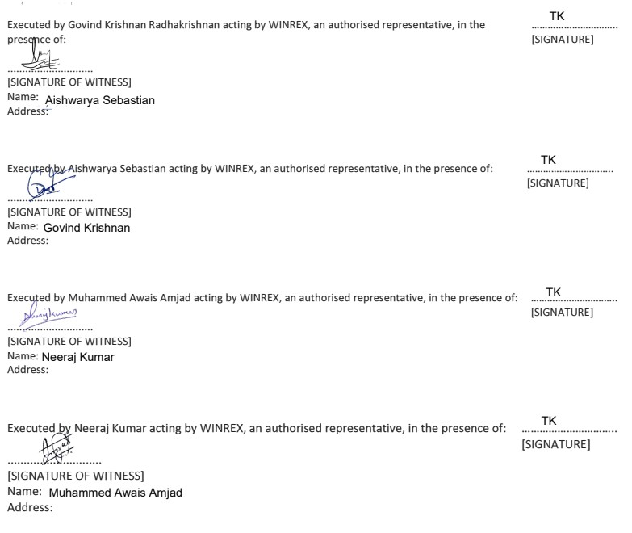

Contents
1. Introduction 9
2.Group Project Management Plan 10
2.1 Group Charter 10
2.2 Role & Work Allocations Per Person 11
2.3 Intended Project Management Approach 11
Task Allocation 11
Tracking & Review 12
2.4 Meeting Format & Schedule 12
3 Projected Costing 13
4 Risk Assessment 14
5 Version Control 14
Mechanism: 14
Responsibility: 14
Policy: 14
7. Change Management System 15
Mechanism: 15
Responsibility: 15
Policy: 15
8. Design, Implementation & Testing of a Restaurant Review System 16
8.1. Functional Requirements 16
8.1.1 User Management 16
8.1.2 Restaurant Management 16
8.1.3 Admin 16
8.1.4 Search & Filtering 16
8.1.5 Restaurant Detail Page 16
8.1.6 Media Handling 17
8.1.7 Verification System 17
8.1.8 Reporting & Abuse Handling 17
8.2. Non-Functional Requirements 17
8.2.1 Performance 17
8.2.2 Scalability 17
8.2.3 Security 17
8.2.4 Reliability 18
8.2.5 Usability 18
8.2.6 Compatibility 18
8.2.7 Maintainability 18
9 Legal Considerations 18
9.1 GDPR Compliance 18
9.2 Copyright & Licensing 18
9.3 Business Verification 18
10. Ethical Considerations 19
10.1 Societal Considerations 19
10.2 Environmental Considerations 19
12. UML Diagrams 19
12.1 Use Case System Diagram 19
Actors 19
12.1.1 Use Case Admin Diagram 21
12.1.2 Use Case Owner Diagram 22
12.1.3 Use Case Customer Diagram 23
12.2 Class Diagram 24
12.3 ER Diagrams 25
12.3.1 ERD LEVEL 0 25
12.3.2 ERD LEVEL 1 26
12.3.3 ERD LEVEL 2 27
12.4 Data Flow Diagrams 28
12.4.1 Level 0 28
12.4.2 Level 1 29
12.5 Activity Diagram 31
12.5.1 System Activity Diagram 31
12.6 System Sequence Diagram 35
13. Interface Design (Wire Frames) 36
13.1 Launching Page 36
Fig 2.8.1 shows the launching page of the system. 36
13.2 Signup page 36
Fig 2.8.2 shows the sign-up page of the system. 36
13.3 Login Page 37
Fig 2.8.3 shows the login page of the system. 37
13.4 Customer Feedback Form 37
Fig 2.8.4 shows the Customer page of the system. 37
13.5 Customer Reviews 38
Fig 2.8.5 shows the launching page of the system. 38
13.6 Restaurant View Page 38
Fig 2.8.6 shows the restaurant view page of the system. 39
13.7 Manage Restaurants 39
Fig 2.8.7 shows the Approve Business Admin page of the system. 39
13.8 Manage Customers 39
Fig 2.8.8 shows the registered customer page of the system. 39
13.9 Admin Dashboard 40
Fig 2.8.9 shows the admin dashboard page of the system 40
14. Database Design 40
14.1 Customer 40
14.2 Restaurant Owner 41
14.3.1 Restaurant info (Embedded) 41
14.3.2 Dishes (Embedded) 42
14.3.3 Restaurant 42
14.4 Feedback 42
15 Testing 43
15.1 Back End Testing 43
Test Restaurant 43
Test Users 46
Test Review 47
15.2 Sample Test Cases 49
Fig 2.10.1 shows the testing page of the system. 49
Fig 2.10.2 shows the testing page of the system. 49
15.3 Integration Test Plan 50
15.4 System Testing 50
16.Submission: Implementation & Completion 51
16.1. Team Meeting Log 51
16.2 Change Management Log 51
16.3 Version Control 52
Mechanism: 52
Responsibility: Each member worked on feature branches. Govind (Backend Lead) approved all mergers. 52
Policy 52
Recorded Commits 52
17 User Guide 52
17.1 Admin User 52
• Approve or reject restaurant registrations 52
• View and delete customers 52
• View and delete guest users 52
• View all feedback 52
• Delete or flag inappropriate reviews 52
17.2 Customer User 52
17.3 Guest User 53
17.4 Restaurant Owner 53
18. Project Management Task Log 53
19. System Execution Guide 53
19.1 Backend 53
19.2 Frontend 54
19.3 Database 54
20. Conclusion 54

1. Introduction
In this project, we developed RestoReview, a restaurant review system designed to reflect how people discover, evaluate, and choose places to eat in today’s digital world. Online reviews strongly influence customer decisions and restaurant success, but they also raise important concerns around trust, fairness, and data responsibility. Our goal with RestoReview was to create a platform that is not only functional, but also reliable, ethical, and practical for real-world use.
RestoReview allows customers to browse restaurants, read and submit reviews, and share genuine dining experiences. At the same time, it gives restaurant owners the ability to manage their information and engage with feedback in a structured way. Administrators play a key role in maintaining the quality and integrity of the system through verification, moderation, and oversight. By clearly separating user roles, we aimed to ensure accountability while keeping the system easy to use.
Throughout development, we followed core software engineering principles, starting with requirement analysis and moving through design, implementation, testing, and documentation. We paid close attention to both functional requirements, such as review submission and search features, and non-functional requirements, including security, performance, and usability. Legal, ethical, societal, and environmental considerations were also integrated into our design decisions, particularly around data protection, content moderation, and responsible system usage.
This documentation presents the complete development journey of RestoReview. It highlights not only the technical outcome, but also how we planned our work, collaborated as a team, managed risks, and responded to challenges. Overall, the project demonstrates our ability to apply theoretical knowledge in a practical and professional context.

2.Group Project Management Plan

2.1 Group Charter

Member Name | Role | Primary Responsibilities
Muhammed Awais Amjad | UI/UX Designer | Create wireframes, mockups, and UI compo- nents; ensure consistent visual identity and  usability across the platform.
Aishwarya Sebastian | Frontend Devel- oper | Implement user interfaces using React.js; in- tegrate APIs; ensure responsive and accessible design; collaborate closely with the de-  signer for consistency.
Govind Krishnan Radhakrishnan | Backend Devel- oper | Develop and maintain server-side logic us- ing Node.js and Express; manage database schemas and operations in MongoDB; ensure  API security and scalability.
Neeraj Kumar | Testing & QA | Design test plans; conduct manual and auto- mated testing; identify bugs and track issues; validate system performance and reliability  before release.

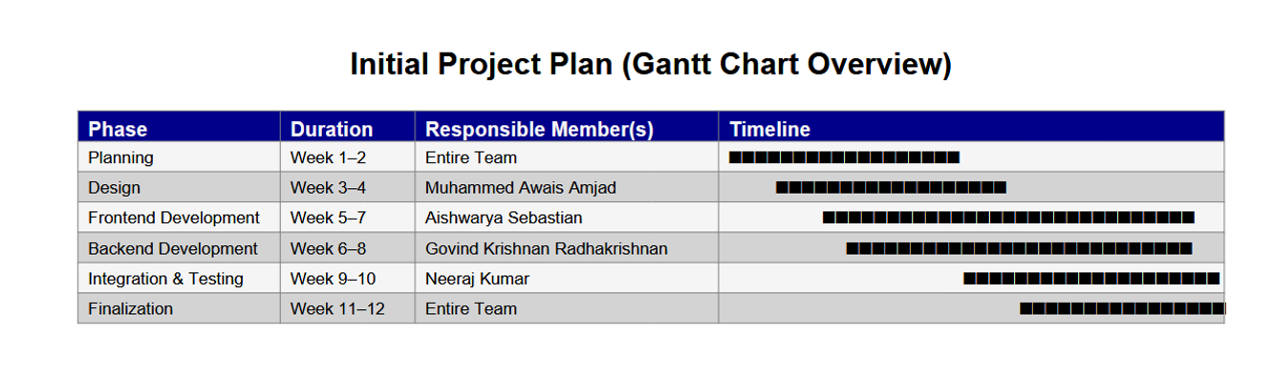

2.2 Role & Work Allocations Per Person
  - Designer (Awais): UI wireframes, color palettes, typography, and responsive layouts.
  - Frontend (Aishwarya): Component structure, API integration, state manage- ment, error handling.
  - Backend (Govind): RESTful APIs, authentication, database schema design, and server deployment.
  - Testing (Neeraj): Unit testing, integration testing, user acceptance testing, performance evaluation.

2.3 Intended Project Management Approach

Task Allocation
Tasks will be divided using the Waterfall Model methodology. Weekly sprints will define clear deliverables, and members will update progress on a shared Trello or Jira board

Tracking & Review
  - Daily short sync (15 minutes) for updates and blockers.
  - Weekly review meetings to assess completed tasks and adjust priorities.

2.4 Meeting Format & Schedule

Type | Frequency | Purpose | Platform
Daily Stand-up | 15 mins (Week-  days) | Quick progress updates | Google Meet
Weekly Review | Every Sunday | Evaluate progress and plan  next sprint | Google Meet
Design Review | Bi-weekly | Approve UI/UX before im-  plementation | Figma / Meet
Final Review | End of sprint | Testing and validation | In-person / Online

3 Projected Costing

Item | Estimated  Cost (GBP) | Notes
Domain Registration & Hosting | £25 | Annual hosting plan and  custom domain
Software Tools (Figma, Canva  Pro, VS Code extensions, etc.) | £40 | UI/UX design and collabo-  ration tools
Development Infrastructure | £0 | Open-source MERN stack  (MongoDB, Express, React, Node.js)
Testing & Deployment | £25 | Cloud testing environments and deployment runtime  costs
Electricity & Internet Usage | £45 | Shared cost of power and  high-speed broadband dur- ing development
Hardware Maintenance | £30 | Laptops, peripherals, and device upkeep during the  project period
Team Communication Tools | £15 | Google Workspace / Slack /  Zoom premium usage
Transportation & Logistics | £20 | Local travel for team mee-  tups and client discussions
House Rent / Workspace Rent Al- location | £60 | Shared team workspace / personal rent allocation for  project duration
Human Resources (Team Salaries  / Stipend) | £400 | Estimated stipend contribu-  tion for all members during the project duration
Contingency Reserve (10% of To-  tal) | £66 | Risk buffer for unexpected  expenses
Total Estimated Cost | £726 | Inclusive of all projected ex-  penses

4 Risk Assessment

Risk Type | Description | Mitigation Strategy
Technical | API or database failure | Maintain regular backups, use  versioned APIs
Schedule | Delay in task delivery | Weekly progress tracking and  buffer periods
Ethical | Data misuse or privacy violations | Ensure GDPR compliance,  anonymize user data
Societal | Misuse of platform content | Add moderation features and  clear terms of use
Environmental | Server power consumption | Use energy-efficient hosting  providers
Legal | Violation of licensing or copyright | Use only open-source or licensed  materials

5 Version Control
Mechanism: Git and GitHub for source code versioning.
Responsibility: Each member maintains a feature branch; Govind (Backend Lead) will approve mergers.

Policy:
- All commits must have descriptive messages.
- Code is peer-reviewed before merging to the main branch.
- Regular backups maintained to prevent data loss.

7. Change Management System
Mechanism: GitHub issues and Trello boards for tracking change requests.

Responsibility:
- Project Lead (Govind) reviews technical impact.
- Designer/Test Lead verifies effect on UI or system quality.

Policy:
- Major changes require team consensus.
- All changes documented with date, reason, and responsible member.
- Rollback plans created for high-impact modifications.

8. Design, Implementation & Testing of a Restaurant Review System

8.1. Functional Requirements

8.1.1 User Management
- Users must be able to register, log in, and log out securely.
- The User can login as Guest User and post reviews also.
- Users must be able to update profiles.
- Admins must have a separate, privileged login.

8.1.2 Restaurant Management
- Verified owners must be able to add, edit, and remove restaurants.
- Restaurant entries must include name, address, coordinates, images, cuisine types, price range.
- System must validate location using Google Maps.

8.1.3 Admin
- Approve/reject Restaurant owners
- Remove inappropriate comments.
- Users must be able to write reviews with:
  - Text comment
  - Ratings (food, service, ambiance, value, cleanliness, overall, etc.)
  - Optional images
- Reviews must be editable or delete by the author.
- Reviews must be moderated by admin for abusive content.

8.1.4 Search & Filtering
- Users must be able to search restaurants by name, location, cuisine.
- Filters must include distance, cuisine, meal type.
- Sorting options: top rated, closest, most reviewed.

8.1.5 Restaurant Detail Page
- Show full restaurant profile.
- Show all reviews with pagination.
- Show average rating calculated dynamically.
- Show restaurant on map.

8.1.6 Media Handling
- Owners can upload images.
- Images must be stored with secure access paths (normalize path, no exposure of server directories).

8.1.7 Verification System
- Owners must upload documents for business verification.
- Admin must approve/reject verification requests.

8.1.8 Reporting & Abuse Handling
- Users must be able to report reviews or restaurants.
- Admin must see all reports and take action (delete review, ban user etc.).

8.2. Non-Functional Requirements

8.2.1 Performance
- API responses should return within <300ms under normal load.
- System must handle at least 50–100 restaurants and thousands of reviews without slowdown.
- Image loading should use lazy loading to reduce bandwidth.

8.2.2 Scalability
- MongoDB must support horizontal scaling (sharding) when data grows.
- Image storage should support CDN delivery for global access.

8.2.3 Security
- Enforce JWT authentication and refresh tokens.
- Passwords must be hashed using bcrypt.
- Validation for:
  - SQL/NoSQL injection
  - XSS
  - CSRF
- File uploads must only allow safe image MIME types.
- Rate-limiting must be applied to:
  - Login endpoint
  - Review posting

8.2.4 Reliability
- System must ensure 99% uptime.
- Daily database backups must be enabled.

8.2.5 Usability
- UI must be mobile-first, responsive, and accessible (WCAG 2.1 AA).
- Language switching must be intuitive.

8.2.6 Compatibility
- System should support all modern browsers (Chrome, Edge, Firefox, Safari).

8.2.7 Maintainability
- Code must follow modular MERN architecture:
  - Controllers
  - Routes
  - Models
  - Services
- API documentation must be provided using Swagger/Postman.

9 Legal Considerations
9.1 GDPR Compliance
Your platform must:
- Collect minimal personal data (email, name).
- Clearly provide privacy policy & data usage.
- Allow users to request account deletion.
- Ensure encrypted transmission (HTTPS).
9.2 Copyright & Licensing
- Images uploaded by users must follow:
  - “User owns what they upload”
  - Platform gets license to display
9.3 Business Verification
- When owners upload documents, you must:
  - Store them securely (encrypted)
  - Restrict access only to admins

10. Ethical Considerations
- System must prevent fake reviews (email verification, owner verification).
- Moderation should avoid bias.
- No manipulation of ratings transparency required.
- Owners cannot delete negative reviews, only report.

10.1 Societal Considerations
- Helps users make informed decisions about food safety, quality, hygiene.
- Gives small restaurants a platform to compete with big brands.
- Must avoid:
  - Allowing harassment
  - Targeted defamation
  - Review bombing

10.2 Environmental Considerations
- Use efficient hosting and minimize server power usage.
- Enable image compression to reduce bandwidth and carbon footprint.
- Encourage digital menus and reduce paper waste indirectly.

12. UML Diagrams

12.1 Use Case System Diagram

Actors
- User
- Restaurant Owner
- Admin
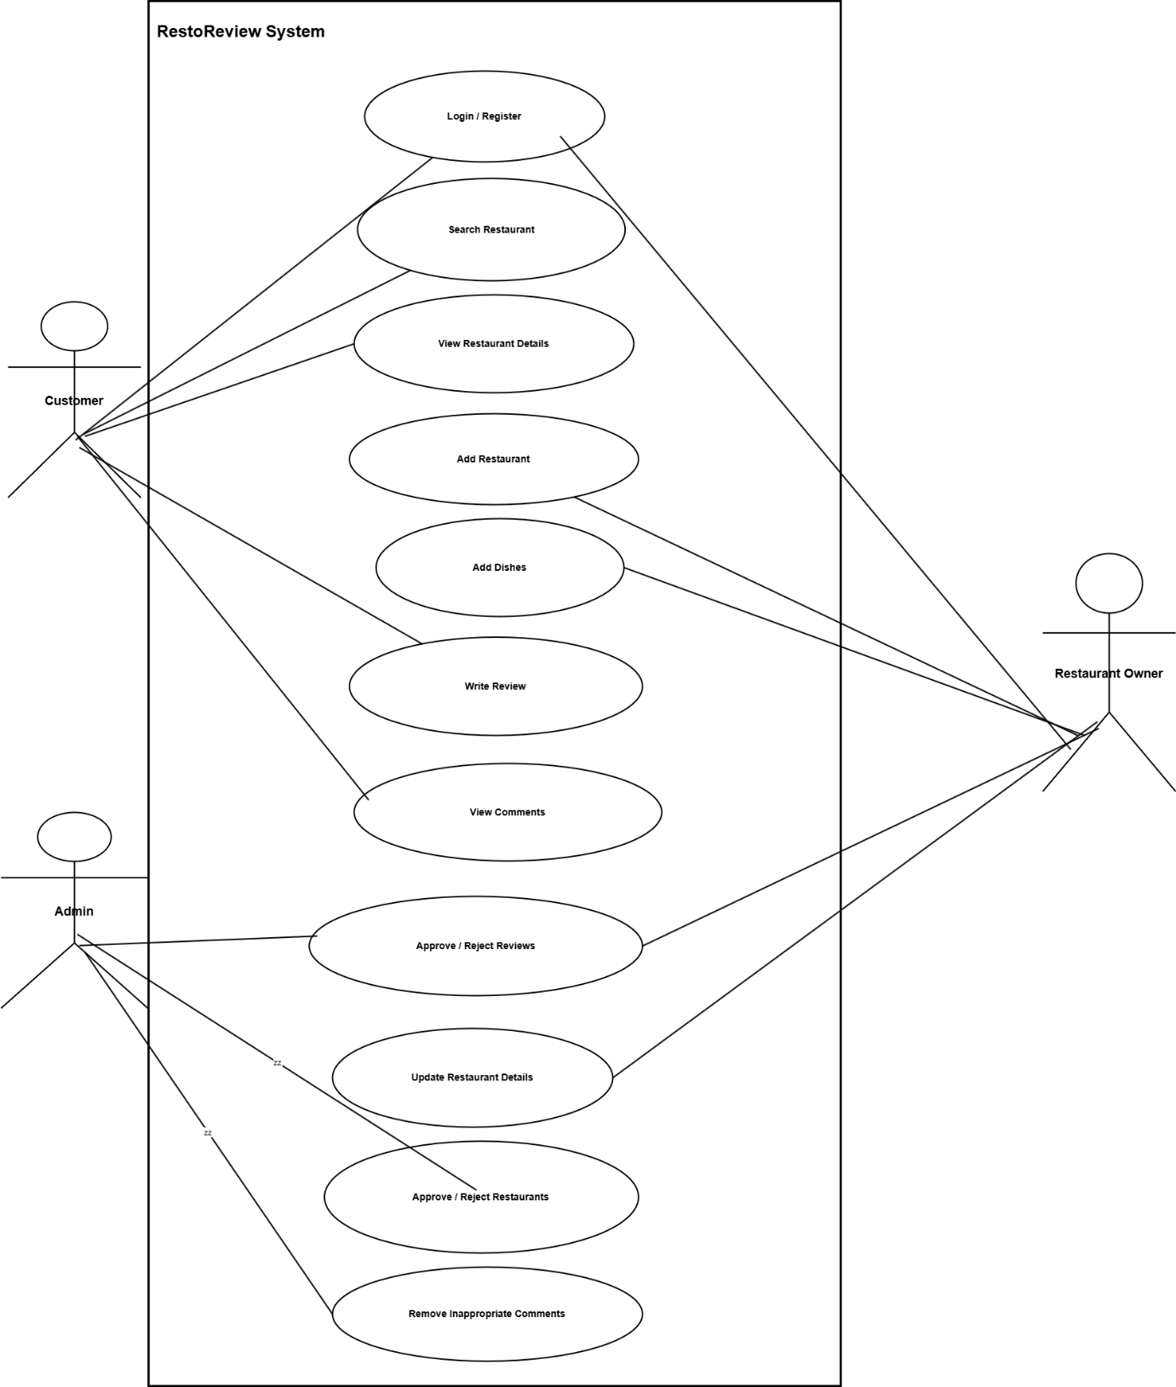

12.1.1 Use Case Admin Diagram

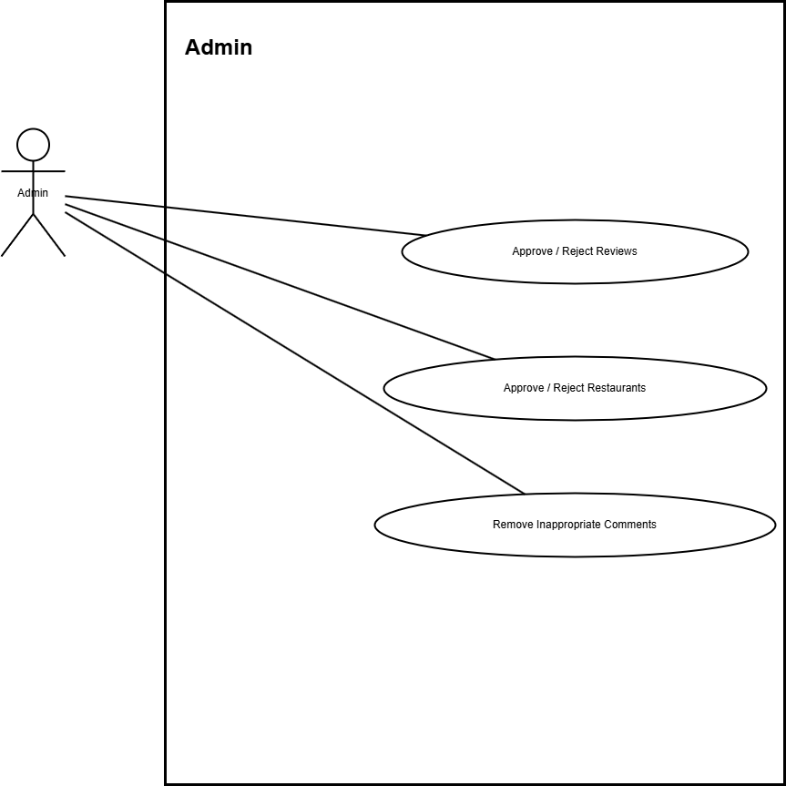

12.1.2 Use Case Owner Diagram
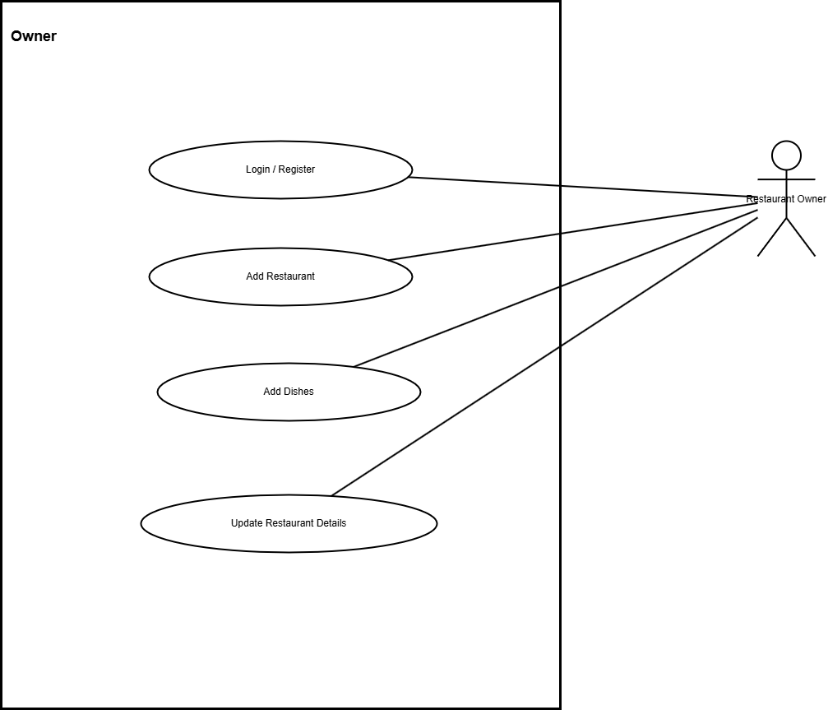

12.1.3 Use Case Customer Diagram
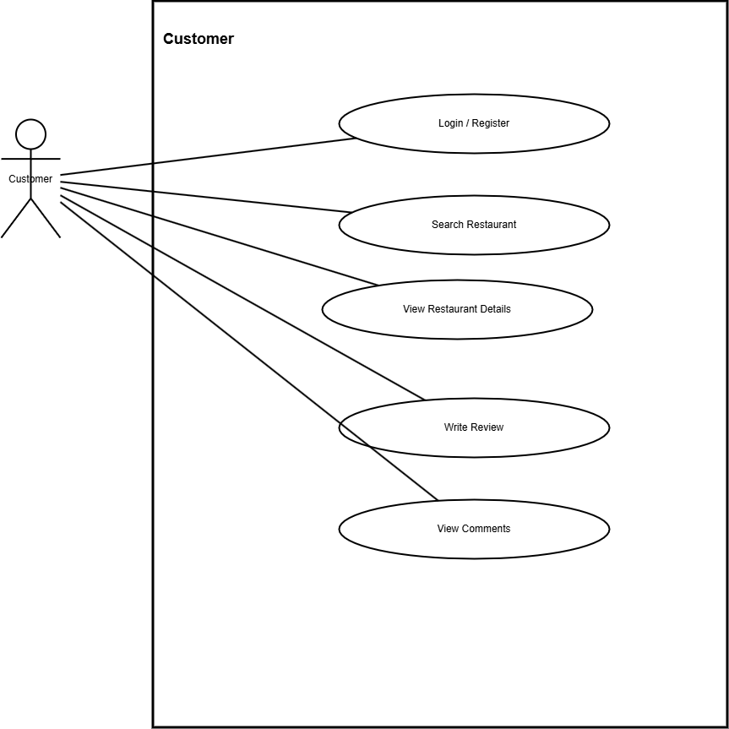

12.2 Class Diagram
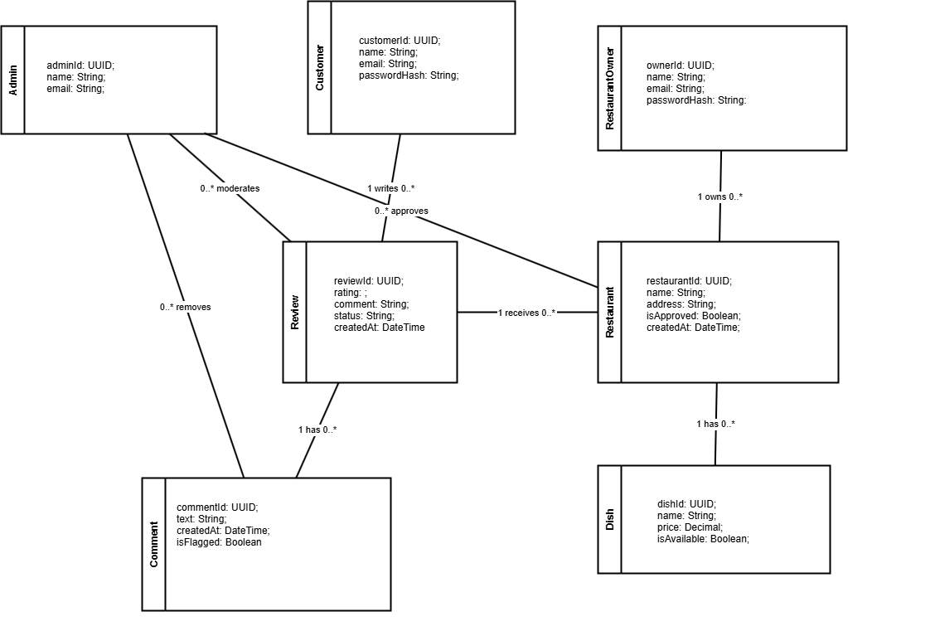

12.3 ER Diagrams

12.3.1 ERD LEVEL 0

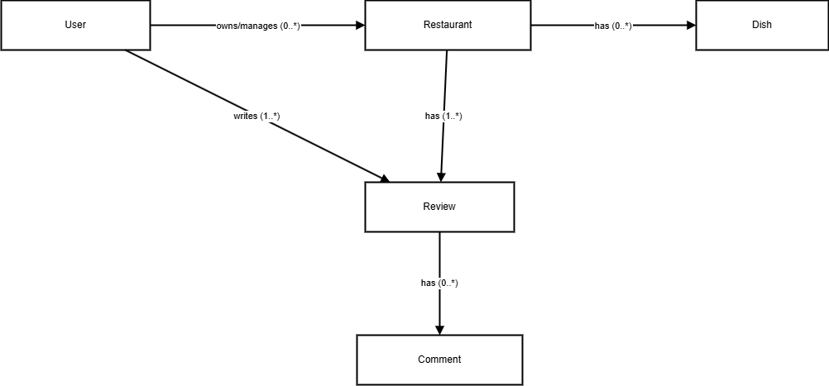

12.3.2 ERD LEVEL 1

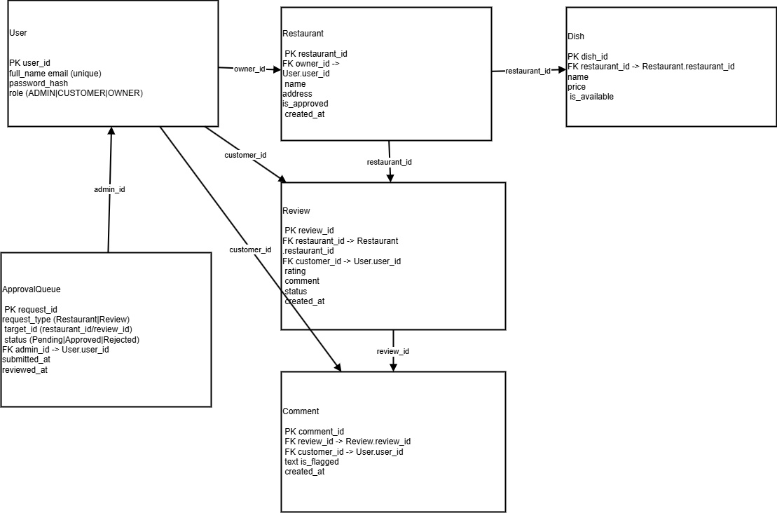

12.3.3 ERD LEVEL 2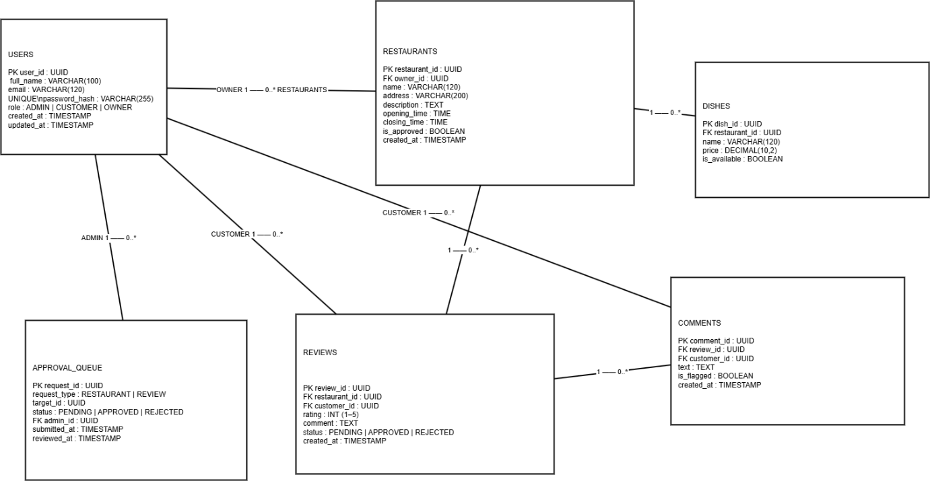

12.4 Data Flow Diagrams

12.4.1 Level 0
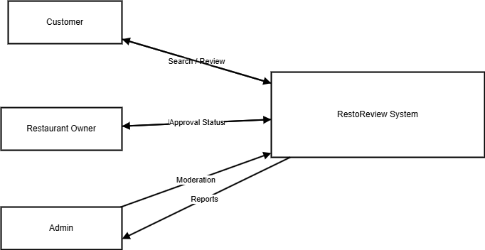

12.4.2 Level 1
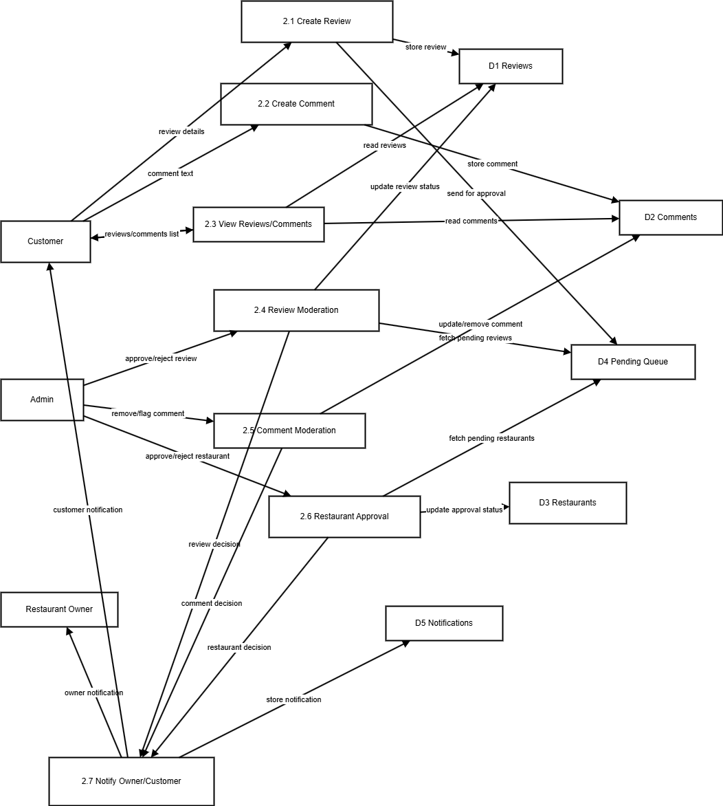

Owner
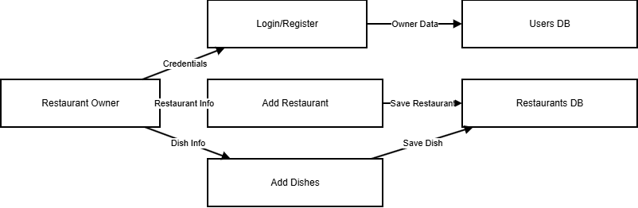

Customer
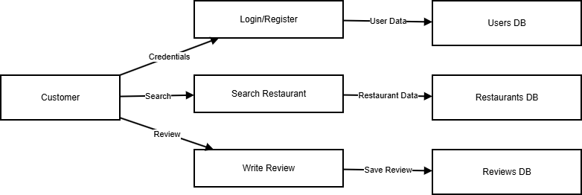

Admin
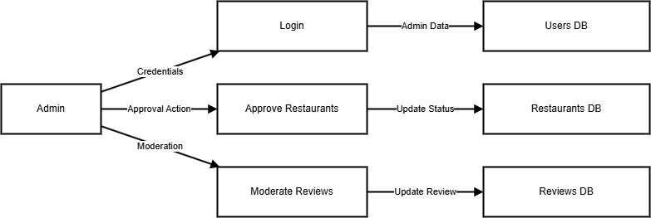

12.5 Activity Diagram

12.5.1 System Activity Diagram
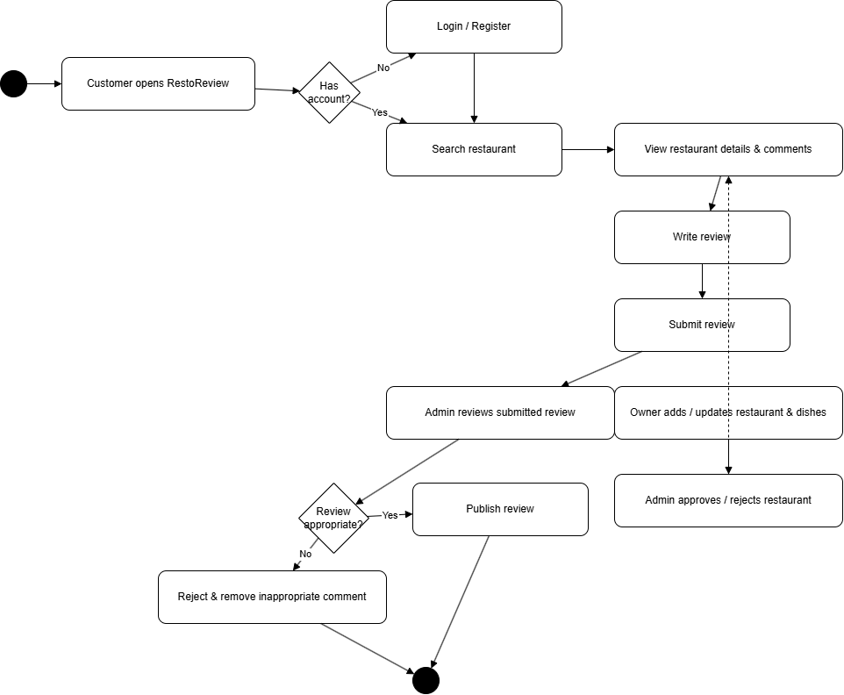
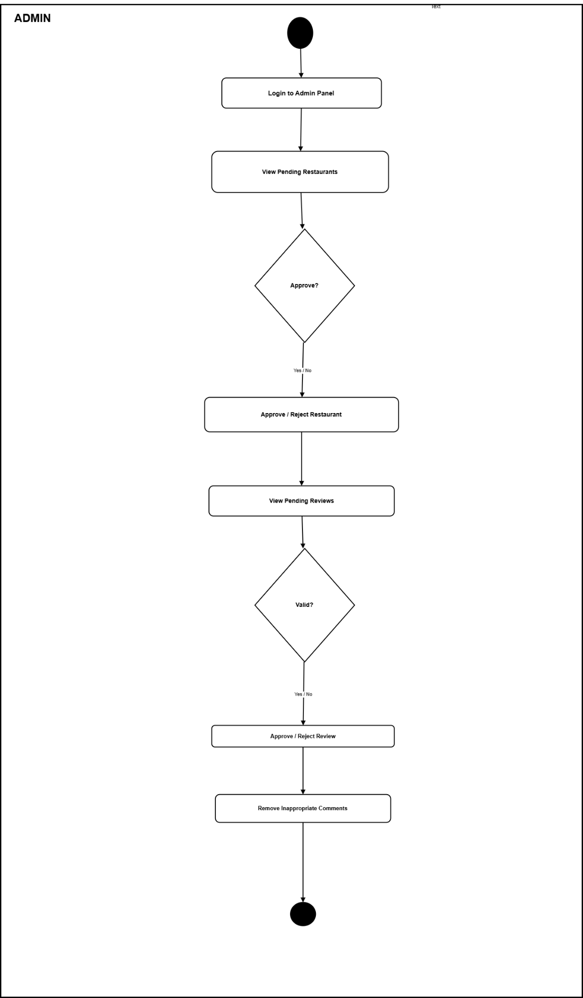
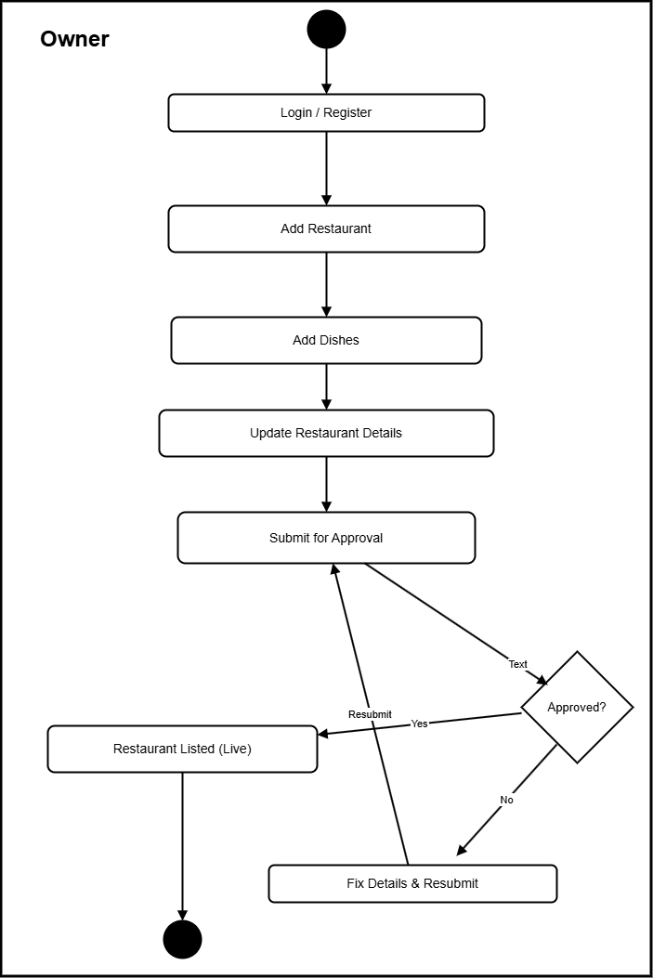
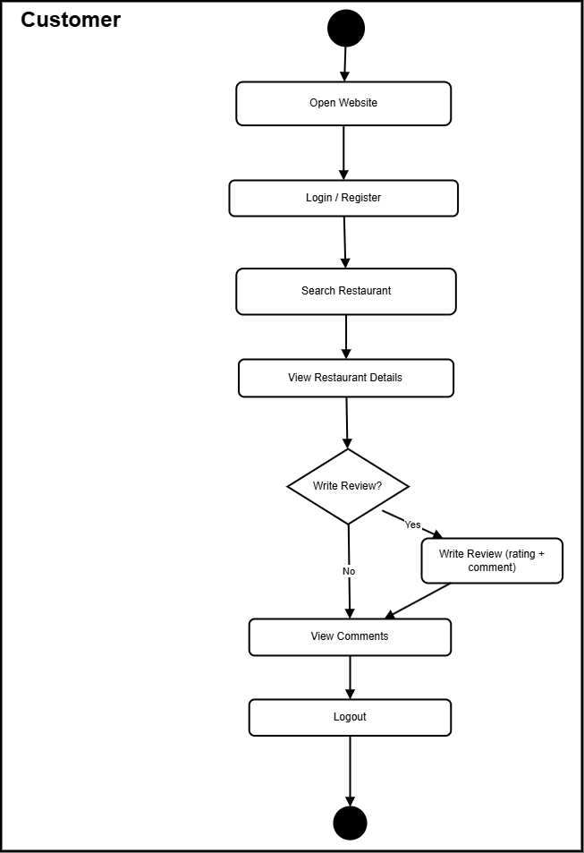

12.6 System Sequence Diagram
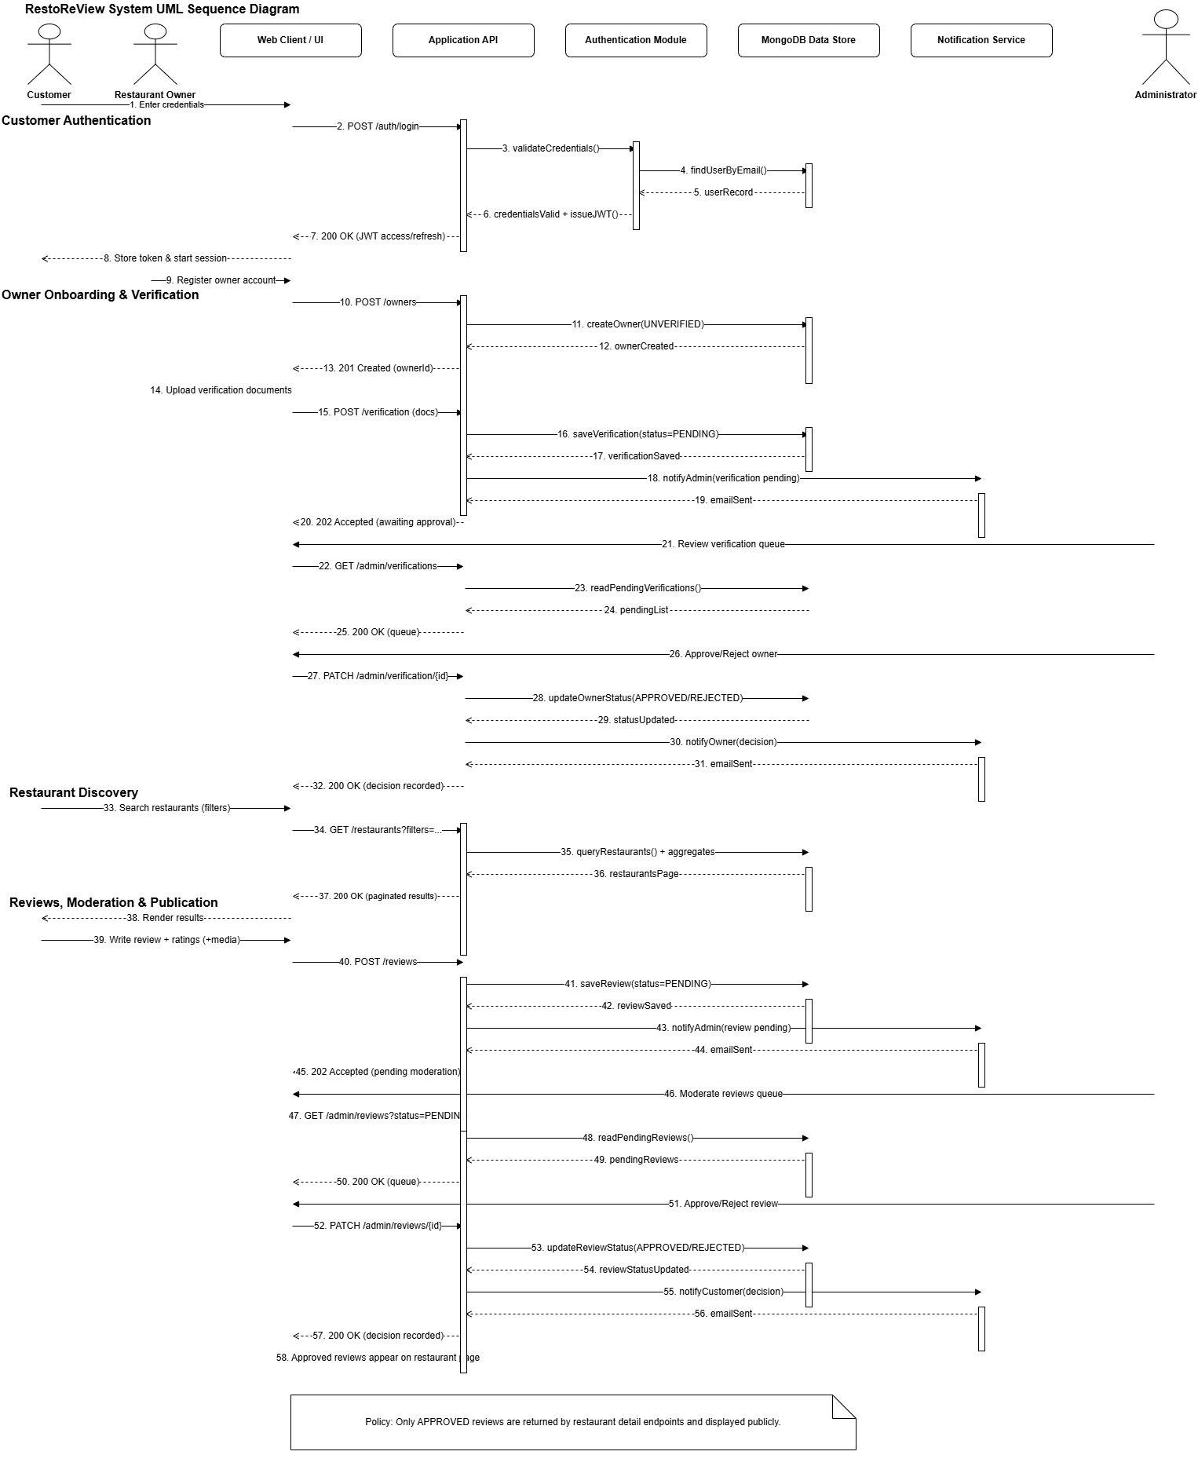

13. Interface Design (Wire Frames)

13.1 Launching Page
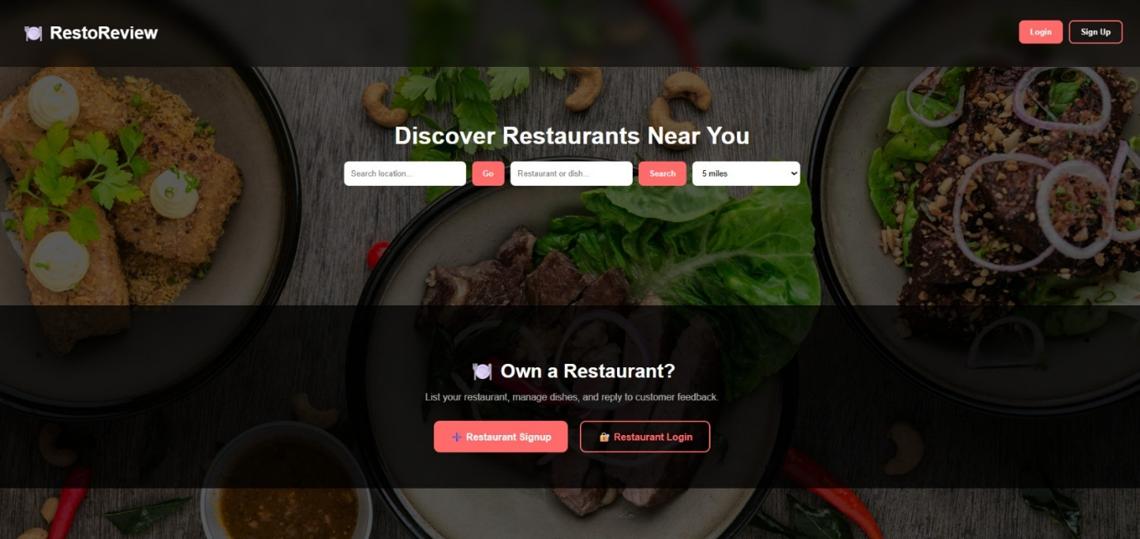

Fig 2.8.1 shows the launching page of the system.

13.2 Signup page
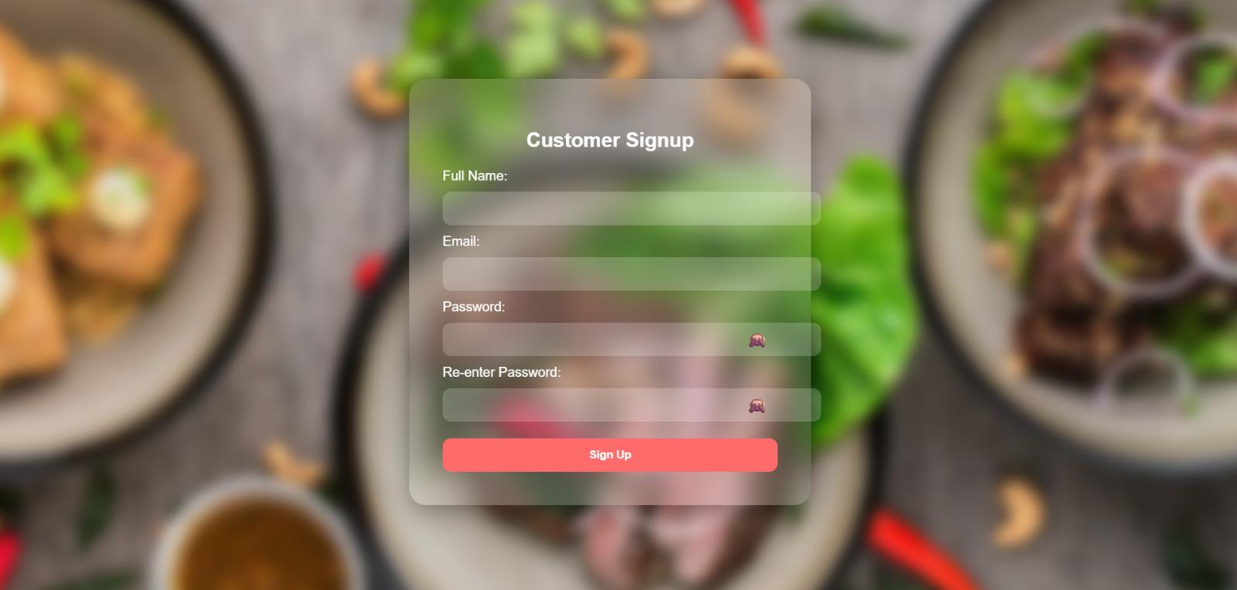

Fig 2.8.2 shows the sign-up page of the system.

13.3 Login Page
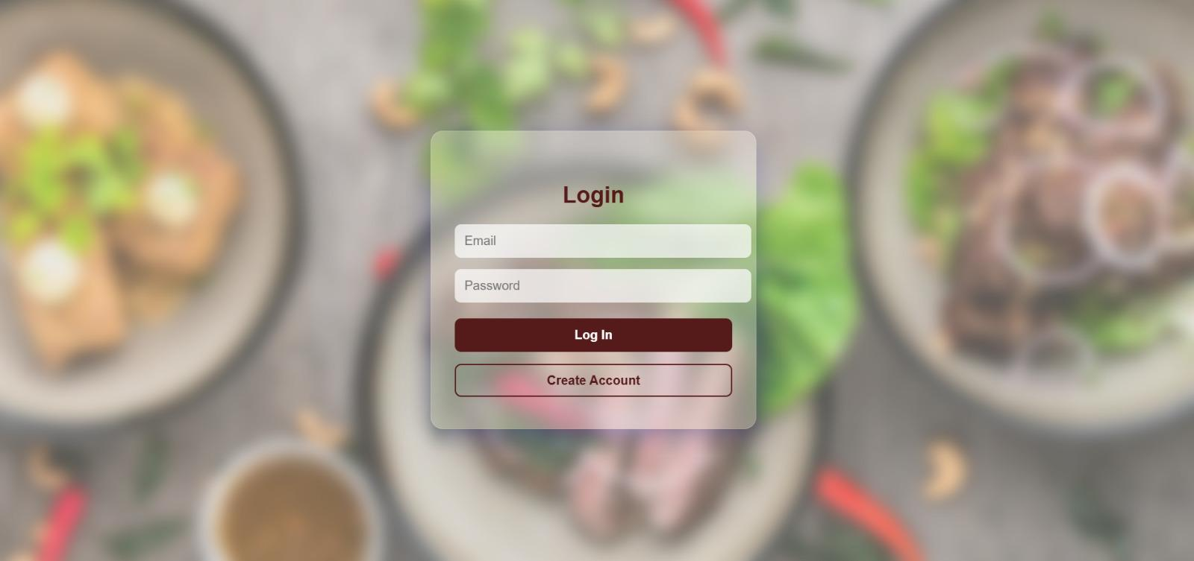

Fig 2.8.3 shows the login page of the system.

13.4 Customer Feedback Form
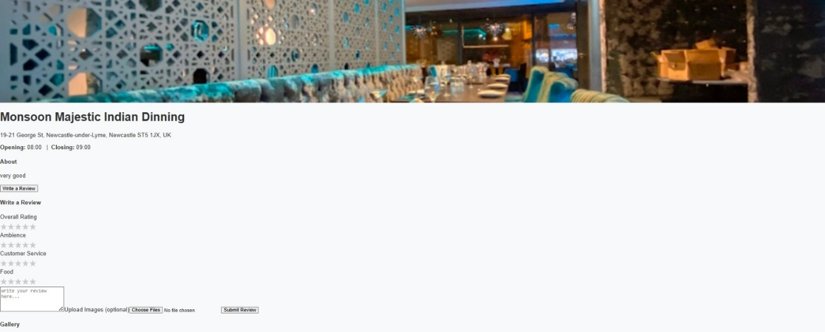

Fig 2.8.4 shows the Customer page of the system.

13.5 Customer Reviews

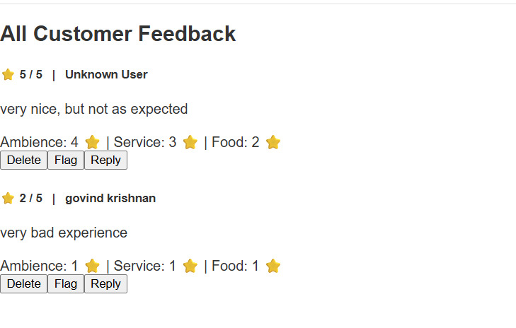

Fig 2.8.5 shows the launching page of the system.

13.6 Restaurant View Page
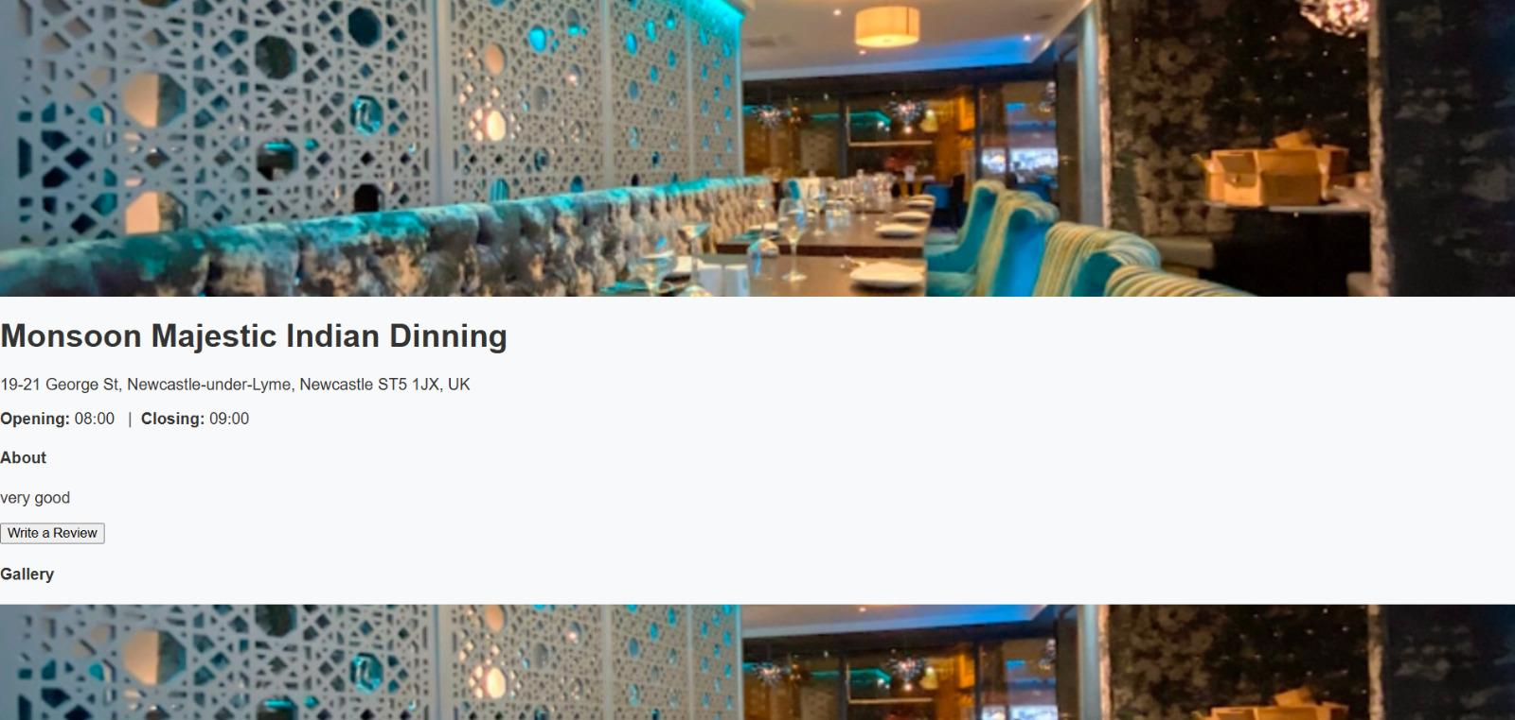

Fig 2.8.6 shows the restaurant view page of the system.

13.7 Manage Restaurants
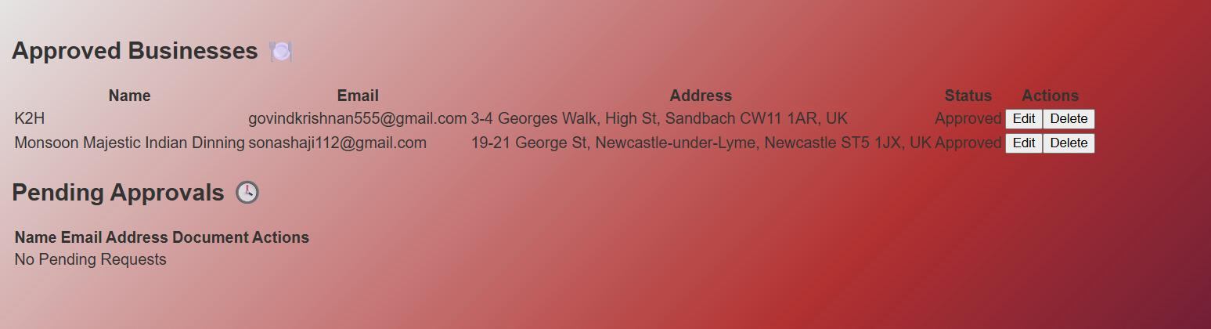

Fig 2.8.7 shows the Approve Business Admin page of the system.

13.8 Manage Customers

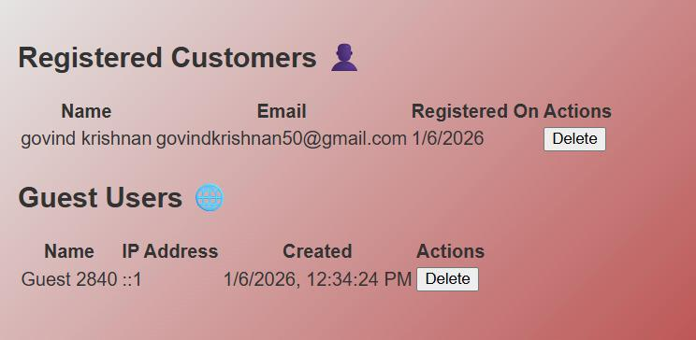

Fig 2.8.8 shows the registered customer page of the system.

13.9 Admin Dashboard
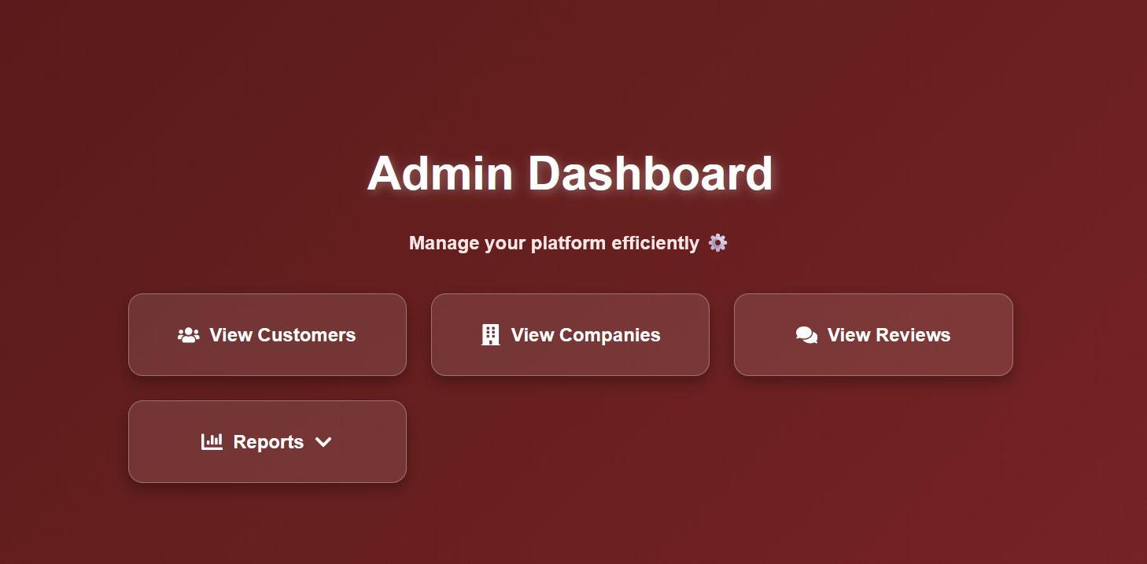

Fig 2.8.9 shows the admin dashboard page of the system.

14. Database Design

14.1 Customer
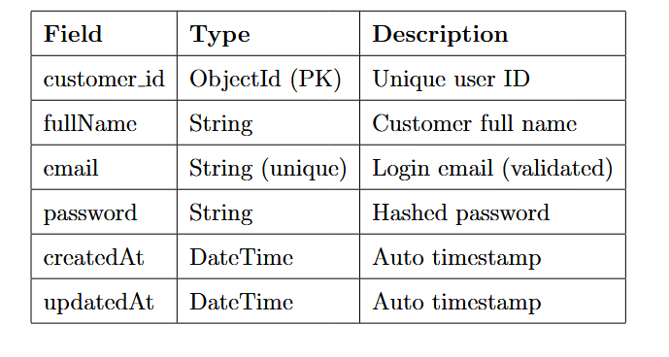

14.2 Restaurant Owner
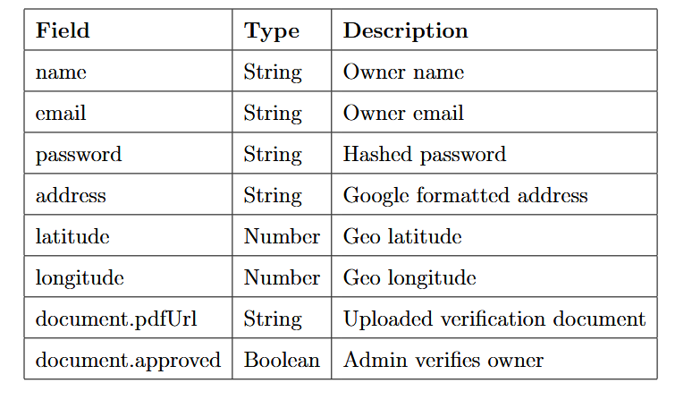

14.3.1 Restaurant info (Embedded)
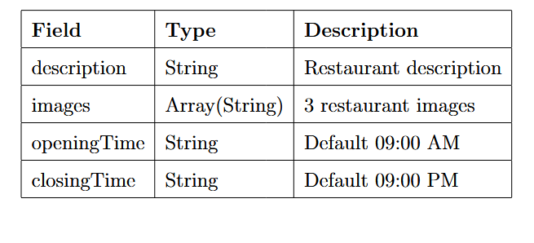

14.3.2 Dishes (Embedded)
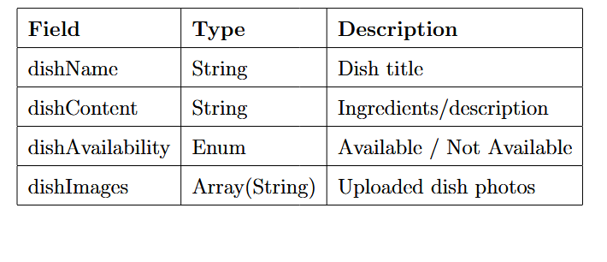

14.3.3 Restaurant
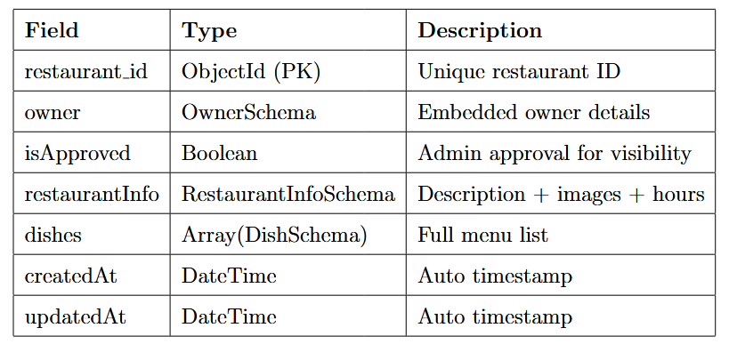

14.4 Feedback
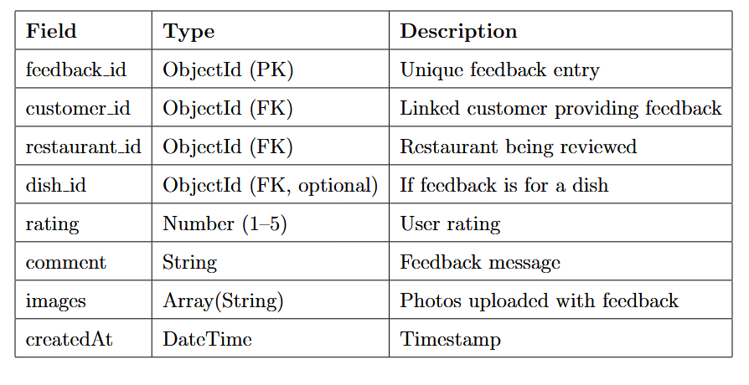

15 Testing

15.1 Back End Testing
Testing of the back-end API was performed using Postman to make HTTP requests of the API. The table below details the tests performed on the API, the expected outcome and the result of the test. Below the table are the data stored in the test database at the point of testing.
ID | Test | Expected outcome | Result
1 | GET: /api/restaurant | To display the Details of all Restaurants Stored | Pass
2 | GET:/api/restaurant/ 6921b4c64f4fbea8942a7c0b | To diplay the Details of a particular Restaurant(Monsoon Majestic) | Pass
3 | GET: /api/restaurant/?search=monsoon | To Return the Searched Restaurant (Monsoon Majestic) | Pass

Test Restaurant
{
_id: "61c5f001aa40ccc58e9ad111",

owner: {
name: "Monsoon Majestic",
email: "monsoon@example.com",
password: "hashedpassword123",
address: "Newcastle-under-Lyme, UK",
latitude: 53.0080,
longitude: -2.2294,
document: {
pdfUrl: "/uploads/docs/monsoon.pdf",
approved: true
}
},

isApproved: true,

restaurantInfo: {
description: "Authentic Indian fine dining with a modern twist.",
images: [
"/uploads/rest/monsoon1.jpg",
"/uploads/rest/monsoon2.jpg",
"/uploads/rest/monsoon3.jpg"
],
openingTime: "10:00 AM",
closingTime: "10:00 PM"
},

dishes: [
{
dishName: "Majestic Thali",
dishContent: "A premium selection of curries, rice, naan, and dessert.",
dishAvailability: "Available",
dishImages: ["/uploads/dishes/thali1.jpg"]
},
{
dishName: "Butter Chicken",
dishContent: "Creamy tomato gravy with tender chicken pieces.",
dishAvailability: "Available",
dishImages: ["/uploads/dishes/butterchicken.jpg"]
}
]
}
{
_id: "61c5f001aa40ccc58e9ad112",

owner: {
name: "K2H",
email: "k2h@example.com",
password: "hashedpassword456",
address: "Sandbach, UK",
latitude: 53.1440,
longitude: -2.3626,
document: {
pdfUrl: "/uploads/docs/k2h.pdf",
approved: false
}
},

isApproved: false,

restaurantInfo: {
description: "Fusion grill and comfort food with bold flavours.",
images: [
"/uploads/rest/k2h1.jpg",
"/uploads/rest/k2h2.jpg",
"/uploads/rest/k2h3.jpg"
],
openingTime: "11:00 AM",
closingTime: "11:00 PM"
},

dishes: [
{
dishName: "K2H Signature Grill",
dishContent: "Mixed grilled platter with sauces.",
dishAvailability: "Available",
dishImages: ["/uploads/dishes/grill.jpg"]
},
{
dishName: "Loaded Fries",
dishContent: "Crispy fries with cheese, chicken, and spicy sauce.",
dishAvailability: "Not Available",
dishImages: ["/uploads/dishes/fries.jpg"]
}
]
}

Test Users
{
_id: "61c5d1110640ccc58e9ad900",
fullName: "Neeraj Sharma",
email: "neeraj@test.ac.uk",
password: "$2b$10$K2n7XQxE8G0u7T6A9p0nXeq0R0q4um3m5VtMgVsu3cN2kVQplRZQG",
createdAt: "2025-01-01T10:00:00.000Z",
updatedAt: "2025-01-01T10:00:00.000Z"
}
{
_id: "61c5d1110640ccc58e9ad901",
fullName: "Govind Krishnan",
email: "govind@test.ac.uk",
password: "$2b$10$eQnDd3bp7qO7l5E2LbsPHe3Tg6D2B3pAvTgEXa3WszKk.t.A0NCUS",
createdAt: "2025-01-01T10:05:00.000Z",
updatedAt: "2025-01-01T10:05:00.000Z"
}

Test Review
{
_id: "6200aa381a1d2f3437ca9001",

customer_id: "61c5d1110640ccc58e9ad900",
restaurant_id: "61c5f001aa40ccc58e9ad111",
dish_id: null,

service: ["serv1"],
cuisine: ["cuis2"],
occasion: ["occ2"],
meals: ["meal1"],

expenseRating: 4,
foodRating: 4,
ambianceRating: 4,
serviceRating: 4,
cleanlinessRating: 3,
speedRating: 4,
valueRating: 4,
allergyRating: 4,

overallRating: 2,
comment: "Food was decent but not impressive.",
images: [],

createdAt: "2025-01-10T10:00:00.000Z"
}
{
_id: "6200aa52920da2f069277d1e",

customer_id: "61c5d1110640ccc58e9ad901",
restaurant_id: "61c5f001aa40ccc58e9ad112",
dish_id: null,

service: ["serv3"],
cuisine: ["cuis3"],
occasion: ["occ3"],
meals: ["meal3"],

expenseRating: 2,
foodRating: 3,
ambianceRating: 1,
serviceRating: 3,
cleanlinessRating: 3,
speedRating: 5,
valueRating: 3,
allergyRating: 3,

overallRating: 3,
comment: "Perfectly fine. Nothing special, nothing bad.",
images: [],

createdAt: "2025-01-20T12:00:00.000Z"
}

15.2 Sample Test Cases
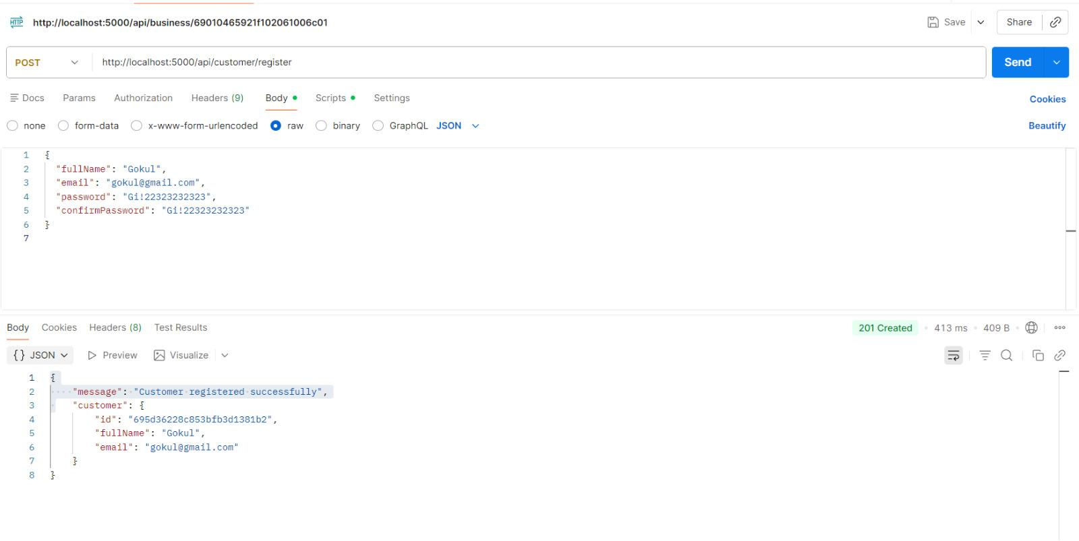

Fig 2.10.1 shows the testing page of the system.

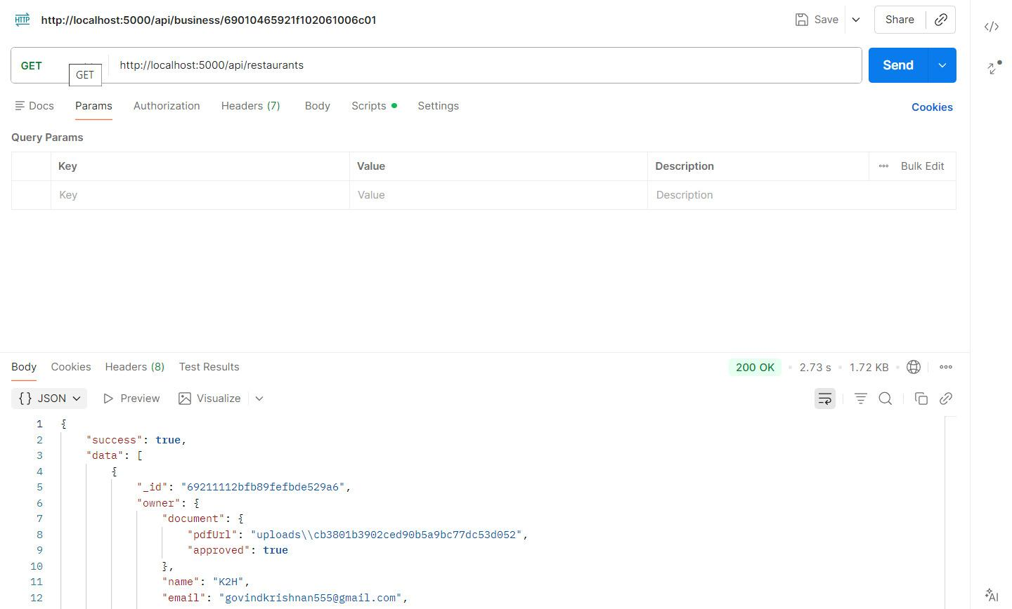

Fig 2.10.2 shows the testing page of the system.

15.3 Integration Test Plan
ID | Test | Expected Result | Actual Result | Outcome
T1 | Search for the Restaurant by name (K2h) | K2h Restaurant Returned by system | K2h restaurant returned by system | Success
T2 | Search for Restaurant by location | System Returned all the Restaurants in that location | System Returned all the Restaurants in that location | Success

15.4 System Testing
ID | Test | Test Data | Expected outcome | Actual outcome | Result
1 | Enter Correct Login Details and submit | Valid email + valid password | Login successful | Login successful | Success
2 | Search Restaurant (monsoon majestic) | Restaurant name: “Monsoon Majestic” | Restaurant details are displayed correctly | Restaurant details are displayed correctly | Success

16.Submission: Implementation & Completion

16.1. Team Meeting Log

Date | Attendees | Agenda | Key Outcomes
19/10/2025 | Govind, Aishwarya,  Muhammad Awais  Amjad | Project initiation | Scope defined and team roles assigned
29/10/2025 | Govind, Neeraj, Aishwarya | Requirement analysis | Functional and nonfunctional requirements  finalised
22/11/2025 | Govind, Aishwarya,  Muhammad Awais  Amjad | Implementation review | Backend structure completed and frontend integration initiated
05/12/2025 | Govind, Neeraj, Aishwarya, Muhammad  Awais Amjad | Testing and finalisation | Bugs resolved and system prepared for submission

16.2 Change Management Log
Change ID | Description | Reason | Status
CM-01 | Feedback module added | Improve engagement | Approved
CM-02 | Authentications refactor | Security enhancement | Approved
CM-03 | Admin approval workflow | Access control | Approved
CM-04 | Mobile UI adjustments | Usability improvement | Approved

16.3 Version Control
Mechanism: Git and GitHub were used for source code versioning.

Responsibility: Each member worked on feature branches. Govind (Backend Lead) approved all mergers.

Policy
- Descriptive commit messages mandatory
- Peer review before merge
- Regular repository backups

Recorded Commits
- 22 November – Govind (backend base structure)
- 28 November – Aishwarya (frontend UI integration)
- 05 December – Govind (final bug fixes)

17 User Guide

17.1 Admin User

Approve or reject restaurant registrations

View and delete customers

View and delete guest users

View all feedback

Delete or flag inappropriate reviews

17.2 Customer User
- Register and login
- Browse restaurants and dishes
- Submit ratings and feedback
- Update personal profile

17.3 Guest User
- Can submit reviews without creating a permanent account
- Is identified internally using a unique Guest ID and IP address
- Has limited access compared to registered users
- Loses access if the guest account is removed by the administrator

17.4 Restaurant Owner
- Log in to the business dashboard
- Manage restaurant details (images, description, opening hours)
- Add, edit, or remove dishes
- Reply to customer feedback

18. Project Management Task Log

Task | Assigned Member | Status
Requirement analysis | Govind | Completed
Frontend development | Aishwarya | Completed
Backend development | Muhammad Awais Amjad | Completed
Testing and validation | Neeraj | Completed
Documentation | Govind | Completed

19. System Execution Guide

19.1 Backend
cd backend npm install node server.js

19.2 Frontend
cd frontend npm install npm start

19.3 Database
MongoDB is used as the database connected via MongoDB Atlas using environment variables.

20. Conclusion
The Restaurant Review Portal successfully delivers a structured and secure platform for discovering restaurants and managing customer feedback. By supporting registered users, guest users, restaurant owners, and administrators, the system ensures flexibility without compromising data integrity. Guest access is carefully controlled through database validation, preventing unauthorised or stale sessions, while administrators retain full oversight of users and reviews. Overall, the application meets its functional objectives by combining usability, role-based access control, and reliable feedback management in a cohesive web-based solution.

